**Game Design**

**Game Mechanics**

**Core Game Play**

Our game will be inspired by Geometry Wars and so it is a Shoot ‘Em Up game. Having the player fight waves of various enemies. The enemies will gain various abilities over time.

**Game Flow**

Close game

Quite

Title Screen

Display controls

Controls

Play

Easy

Difficulty

Medium

Hard

Through the difficulty that the player chooses, the enemies will spawn at different rates at the beginning of the game. The player will then survive for as many rounds as possible, gaining points for each time they destroy an enemy. Once the player reaches a certain amount of score then the next wave of enemies will begin.

**Characters**

S.T.E.V.E (Super Tatum Evolutionary Vapor Enigma) is the character the user will be playing as. He is an ever enhancing space ship, which was created to defend Earth from the alien ships. The starting enemies are the lowest and the least dangerous, after time, the enemies will slowly advance to the highest and most dangerous enemies.

**Game Play Elements**

The player will be able to acquire their lives if they lose them, they will also be able to acquire weapon upgrades, and they will also be able to get their health back. All of this will be accessible through the shop.

**Artificial Intelligence**

The lower difficulty AI will try and run into the player, following them around the map until so. The higher difficulty AI will try and shoot the player, which damages them. Once the player is run into/shot then they will lose a life point and will be slowed for a little while.

**Multiplayer (Not definite)**

There will be a head-to-head game mode where two players (player 1 and player 2) will fight each other, and whoever shoots the other one down first, wins. There will be another game mode that will be co-operative, where, player 1 and player 2 will fight oncoming waves of enemies and will try to survive.

**User Interface & Flow Chart**

Close game

Quite

Title Screen

Display controls

Controls

Play

Multiplayer

Single-player

Hard

Medium

Easy

1 v 1

Co-Operative

Difficulty

Lose Screen

Win Screen

Quit

Replay

Replay

Quit

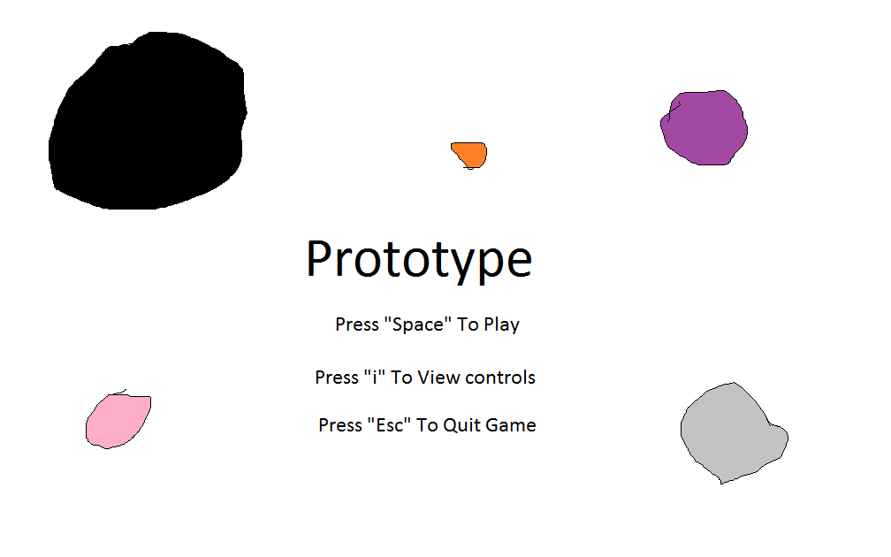**Mock-ups**

**GUI Objects**

The menus have clickable GUI.

**Art and Video**

There is art for, the background, the ship, the various enemies, the shop.

**Overall Goals**

Our overall goal is to create a functioning game with no bugs, have the player be able to move freely and have the enemies spawning in a certain radius around the player. The enemies will hopefully spawn over a certain amount of points that the player earns.

**2D Art and Animation**

* **GUI**
  + The game will have a main menu and a pause menu for mid-game.
* **Terrain**
  + An image background.
* **Game Play Elements**
  + The player and the enemies are sprites, the player has a fire particle effect for their thruster. The player has a default gun, but can pick up upgrades that increase the fire rate. The player has five damage states, the first one, Full Health, the second one, Three Quarters Health, the third, Half Health, the fourth, One Quarter Health and the fifth, No Health. The player will also have three lives that will go through this cycle.
* **Special Effects**
  + The only special effect is the player’s particle thruster.

**Sound and Music**

**Overall Goals**

We want a fast paced mood so we will have quick music like Space Invaders has towards the end of the game.

**Sound Effects**

We will have an explosion sound effect for when the player or the enemies die. There will be a “pew pew” for when the player shoots. The explosion sound effect will be called when the player/an enemy dies, the bullet sound effect will be drawn when the player fires a bullet. The bullet sound effect will be called BulletEffect, and the explosion sound effect will be called ExplosionEffect.

**Music**

A 80s remix of Sandstorm by Darude plays throughout the whole game, it is fast paced which fits the gameplay.

**Story**

The alien race, Tiam, created shape looking ships and attacked Earth. Earth had to defend themselves, so they created S.T.E.V.E (Super Tatum Evolutionary Vapor Enigma) which could hopefully eradicate the aliens from earth’s atmosphere. Based on how the player goes, he will continue that story by either winning or losing.

**Level Requirements**

**Level Diagram**

Depending on whether the player chooses to play ‘Wave Mode’ or ‘Survival Mode’ than the level design will be a little different to each other. In ‘Wave Mode’ the player will go up against ten waves. In ‘Survival Mode’ a constant flow of enemies will spawn and player must survive for as long as possible.

**Asset Revelation Schedule**

All assets are revealed as soon as the player starts the game.

**Level Design Seeds**

The level for ‘Wave Mode’ is to destroy all the enemies that come in each wave. The level for ‘Survival Mode’ is to keep fighting until the player dies.

**Controls**

Player 1 uses the WASD keys to move and space bar to shoot. Player 2 uses the arrow keys to move and shift/ctrl to shoot (ctrl is in case the user has sticky keys). The mouse is used to navigate the menus.

**Target Audience**

The target audience is everyone above 6 years old.

**Who Completed which Feature?**

**Jeremy Craig:** Sound, Wave Game mode, Particle Effect, Game Design Doc.   
**Daniel Heath:** (the first) Player, Shop, Numerous bug fixes throughout all coding, Wave Game mode.  
**Ethan Holdsworth:** All Enemies, Intersects for Entities Collisions.  
**Braydon Keegan:** Main, Game States, Player 2, UI.